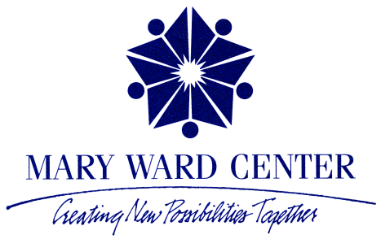

3215 E. 91st Street
Chicago, IL 60617
(773) 734-2420

The Mary Ward Center was established in the South Chicago community of the city of Chicago to address the language needs of local Hispanic immigrants. The mission of the Mary Ward Center is to create new possibilities for the people of South Chicago by providing opportunities for educational development. Services are provided regardless of faith, ethnicity, gender, or income. As a ministry of the Institute of the Blessed Virgin Mary, Mary Ward Center embraces the Institute’s direction statement that calls members to stand in a direct way with the powerless, those on the fringes of society.
The South Chicago community is rich in immigrant history dating back to the early 19th century with the settling of eastern Europeans. Today’s residents are Mexican Americans, other Hispanic groups and African Americans. About 45% of the population of South Chicago is Hispanic.
The needs of the community are many. It is an underserved area due to the changing neighborhood and poverty. When Mexicans were asked to come and work in the thriving steel industry, many came and settled in South Chicago. The steel industry was shut down and the people and area were left with no income, jobs or opportunities. Many came as undocumented and this added to their problems as they now searched for jobs. The need for English skills was great. As children attended school, and learned and spoke English, at home Spanish was and is still widely used. As adults learn English they are able to help their children with homework and converse with teachers. Their own education was usually one of interruptions, some never attended school and others dropped out as they were needed to work and help support the family. Today, many wish to become citizens and need English for their citizenship test and interview. Learning English has now become a priority for a better life here in the United States.
In the spirit of Mary Ward, founder of the Institute of the Blessed Virgin Mary, the Center recognizes the individual worth of persons and journeys with them to foster their true potential.
We offer assistance in basic education, such as; one-on-one tutoring in reading, writing, grammar, listening and speaking skills, basic computer training, and activities for spiritual growth and personal enrichment. In addition to the above, a women’s group (Mujeres de Luz), Women of Light, was added in the fall of 2011.
A unique aspect of the services we offer is that they are most frequently provided in a one-on-one setting. This intensive approach allows staff and volunteers to develop and implement an individualized plan that addresses each participant’s needs and obstacles to learning. Individual instruction enables them to learn at their own pace, which tends to be faster than in a group. As participants increase their communication skills and enjoy its success, they are also building the foundation to become lifelong learners in their new homeland. Two Conversation Classes have been added to help in day to day survival situations.
Mary Ward Center has been in operation since 1999. Staff efforts have helped the student list grow to between 120 and 150 men and women served each year. It is interesting to note that more than 1000 people have passed through our doors since the Center began. At least 23 have become citizens and many have better jobs. More than 15 trained volunteers from the community and as far as Wheaton assist the Center so students receive a stable one-hour of individual instruction per week at the same hour on the same day. Despite the demands of family life and work, our students come to Mary Ward Center anxious to learn. Staff and volunteers are committed to flexible scheduling during the day and evenings. Our classes begin at 9:00 a.m. and the last hour class ends at 8:00 p.m. in the evening. We do not teach Friday afternoons or on the weekends.
Basic to more advanced computer classes are offered. Our computer classes have four students per class. They, too, learn at their own pace. Rosetta Stone, Mavis Beacon Teaches Typing, Microsoft Word and Excel are basic to the curriculum. In addition to these skills, the students are introduced to the Internet and various skills connected to it.

Mary Howard Moriarty, IBVM
Mary Ward Center
June 6, 2014

