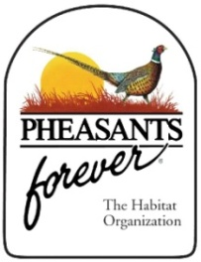**Pheasants Forever & Quail Forever**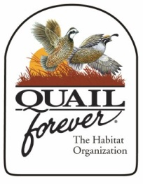

***The Habitat Organization***

***JOB VACANCY ANNOUNCEMENT***

**Regional Representative**

***Southern Missouri, Arkansas, Louisiana***

***APPLICATION DEADLINE:*** Open until filled.

***POSITION SUMMARY:***

Pheasants Forever and Quail Forever are seeking individuals with the talent, passion, and desire to promote and grow the nation’s leading upland wildlife habitat conservation organization. The Regional Representative position is responsible for grassroots mission delivery by engaging communities, chapters, volunteers, and members within the assigned region. The successful applicant will assist chapters to maximize their fundraising and mission impact at the local, state, and national levels. Additionally, the Regional Representative will work with Development teammates to identify, cultivate, and solicit mission-driven donations.

***RESPONSIBILTIES and EXPECTATIONS:***

* Provide proactive guidance and customer service to chapters across the region. A primary focus of the duties will include increasing memberships, merchandise sales, and facilitating contributions to national and state programs.
* Identify and develop prospects for PF and QF fundraising campaigns.
* Create new chapters and restructure existing chapters to encourage strong volunteer committees that are striving to fulfill the mission of the organization.
* Work with chapters to increase the efficiencies and effectiveness of fundraising events.
* Develop and use methods of regular communication with chapter leaders to keep our volunteers informed and motivated about the organization’s mission, activities, goals, and fund-raising efforts.
* Work as a team member to develop and deliver a consistent message about our habitat, education and outreach and advocacy mission.
* Promote the PF and QF mission, as well as related fundraising efforts, to support the organization.
* Plan and conduct district meetings and state meetings with chapters.

***MINIMUM QUALIFICATIONS:***

* B.A./B.S. in Marketing, Education, Business, Wildlife Biology, or related field with practical experience. Prior experience working with volunteers and fundraising preferred.
* Thorough knowledge of PF and QF’s mission, model, and activities.
* An energetic, well-organized, detailed, self-starter who has a strong record of leadership and teamwork.
* Superior interpersonal and presentation skills and the ability to collaborate effectively with diverse constituencies, including volunteers, partners, and team members are a must.
* Demonstrated experience as an innovative and creative thinker with a proven success of following-through with their ideas.
* Demonstrated set of skills that bring strong organizational skills, leadership, and sales to the position.
* Demonstrated ability to work and interact with sportsmen.

***Compensation and Location:*** Starting salary and benefits commensurate with experience and qualifications. Location is negotiable within the assigned territory.

***To Apply:*** Visit our Recruitment website at: [www.pheasantsforever.org/jobs](http://www.pheasantsforever.org/jobs). Please combine your cover letter, resume and three references in a Word document or PDF file before uploading to the Recruitment website. The cover letter should share why you are interested in the position.

***For more information:*** Contact Matt Christensen or Jerry McDonald, Pheasants Forever and Quail Forever’s Field Services Managers, at [mchristensen@pheasantsforever.org](mailto:mchristensen@pheasantsforever.org) or [jmcdonald@pheasantsforever.org](mailto:jmcdonald@pheasantsforever.org).

***Pheasants Forever, Inc is an Equal Opportunity/Affirmative Action employer. All qualified applicants will receive consideration for employment without regard to race, religion, color, national origin, sex, sexual orientation, gender identity, age, status as a protected veteran, status as a qualified individual with disability, or any other category that may be protected by law.***