CHIPPEWA NATIONAL FOREST, EASTERN REGION
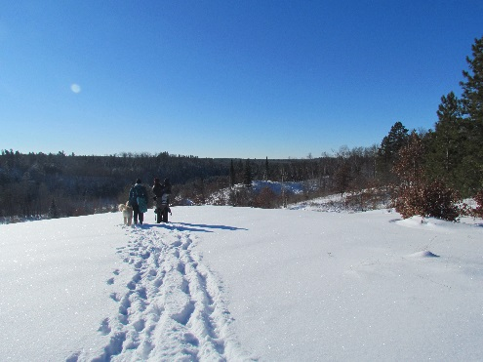
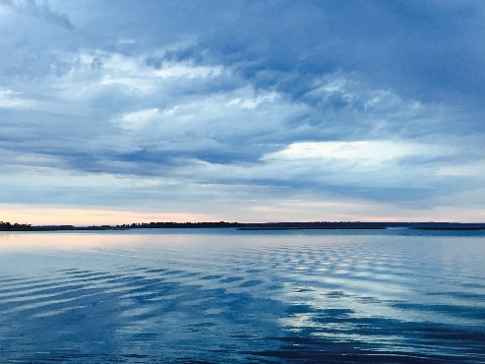
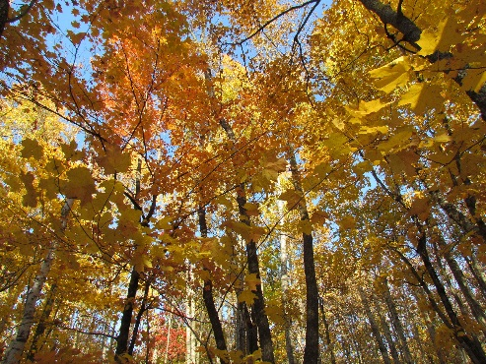

OUTREACH NOTICE
Biological Science Technician (Natural Resource)
GS-0404-05/06/07
Duty Station: Deer River

The Chippewa National Forest is seeking candidate(s) for permanent seasonal positions for Biological Science Technicians GS-0404-5/6/7.

Work Schedule | Vacancies | Grade Level | Duty Station
Permanent Seasonal 18/8 | 3 | GS-7 | Deer River, Minnesota
Permanent Seasonal 18/8 | 1 | GS-5/6/7 | Cass Lake, Minnesota
Permanent Seasonal 13/13 | 1 | GS-5/6/7 | Cass Lake, Minnesota

The Permanent Seasonal 18/8 and 13/13 positions are guaranteed full-time work for 18 or 13 pay periods and when not working, will be placed in non-pay/non-duty status. Situational Telework (Referred to as AD HOC, episodic, unscheduled, and intermittent) may be authorized.

To be considered for the position you must apply to the Open Continuous Register Job Announcements on USAjobs.gov you must apply by October 31, 2022, the links to the job announcements are below.

PLEASE read the Job Announcements thoroughly, you may apply to both if you are eligible; we are using both DEMO (open to the public) and Merit (Government wide and all hiring authorities)

Information about eligibility can be found here: USAJOBS Help Center | Which jobs am I eligible to apply for?

Biological Science Technician (MERIT announcement)

Biological Science Technician (DEMO announcement)

Major Duties
- Schedule, organize, and execute field projects for detecting, identifying and evaluating natural resource problems, i.e., water, land, plants, animals, and soils.
- Compile and summarize data obtained from aerial and ground surveys including natural resource monitoring, evaluations, and pilot tests conducted as part of the project.
- Conduct routine analyses; and provide the data to professional personnel.
- Use computer programs to organize the data conducted.
- Using prescribed procedures, resolves common administrative, technical and/or safety concerns related to the project.
- Provide technical knowledge and skills to address specific issues and resolves.

Please see the USDA Forest Webinar links below for helpful information when applying for federal jobs:

- Tips for Job Seekers
- Hiring Eligibility and Qualifications
- How to Write a Federal Resume
- Navigating USAJOBS.gov

About the Forest

The Chippewa National Forest is located in north central Minnesota, approximately 200 miles northwest of Minneapolis/St. Paul, and encompasses about 1.6 million acres which includes approximately 666,600 acres of checkerboard ownership with other public, private, and tribal lands interspersed. The Forest Supervisor’s office is located in Cass Lake, MN, with district offices in Blackduck, Deer River and Walker. The Forest was the first National Forest established east of the Mississippi River in 1908 and has a rich cultural history spanning at least 10,000 years including pre-European contact sites, logging camps, and Ojibwe and Euroamerican homesteads. Over 40% of the Forest is within the Leech Lake Indian Reservation and forest employees coordinate and consult closely with the Leech Lake Band of Ojibwe.

Water is very abundant on the National Forest and includes the Mississippi River headwaters region along with over 1300 lakes, 923 miles of rivers and streams, and 400,000 acres of wetlands providing world class fishing opportunities to visitors. Mixed northern conifer and hardwoods blanket the rolling uplands of the Chippewa. Recreation opportunities abound with canoeing, camping, boating, swimming, hiking, biking, horseback riding, cross-country skiing, snowmobiling and scenic drives throughout the area.

For further information about the Forest, see our website: https://www.fs.usda.gov/Chippewa

DUTY LOCATIONS

Deer River, MN
The Deer River is the “Gateway to the Chippewa National Forest” rich in history, heritage, and scenic beauty! Surrounded by lakes, rivers, and forests, it’s a community with an abundance of outdoor recreational opportunities to enjoy including hiking, fishing, camping and winter snowmobiling. Deer River Chamber of Commerce

SURROUNDING COMMUNITIES

Grand Rapids, MN
Grand Rapids hosts a population of 11,097 people. Known for recreation opportunities, scenic beauty of the Highway 38 National Scenic byway, preserved heritage and vibrant arts and entertainment. Grand Rapids Chamber

In accordance with Federal civil rights law and U.S. Department of Agriculture (USDA) civil rights regulations and policies, the USDA, its Agencies, offices, and employees, and institutions participating in or administering USDA programs are prohibited from discriminating based on race, color, national origin, religion, sex, gender identity (including gender expression), sexual orientation, disability, age, marital status, family/parental status, income derived from a public assistance program, political beliefs, or reprisal or retaliation for prior civil rights activity, in any program or activity conducted or funded by USDA (not all bases apply to all programs). Remedies and complaint filing deadlines vary by program or incident.
Persons with disabilities who require alternative means of communication for program information (e.g., Braille, large print, audiotape, American Sign Language, etc.) should contact the responsible Agency or USDA's TARGET Center at (202) 720-2600 (voice and TTY) or contact USDA through the Federal Relay Service at (800) 877-8339. Additionally, program information may be made available in languages other than English.
To file a program discrimination complaint, complete the USDA Program Discrimination Complaint Form, AD-3027, found online at How to File a Program Discrimination Complaint and at any USDA office or write a letter addressed to USDA and provide in the letter all of the information requested in the form. To request a copy of the complaint form, call (866) 632-9992. Submit your completed form or letter to USDA by: (1) mail: U.S. Department of Agriculture, Office of the Assistant Secretary for Civil Rights, 1400 Independence Avenue, SW, Washington, D.C. 20250-9410; (2) fax: (202) 690-7442; or (3) email: program.intake@usda.gov.
USDA is an equal opportunity provider, employer, and lender

