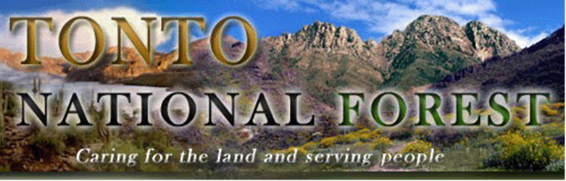
OUTREACH NOTICE
Pathways Indefinite Intern Positions

USDA Forest Service, Southwestern Region
Tonto National Forest
Duty Location: Globe Ranger District, Globe, AZ (1 position available)
Duty Location: Tonto Basin Ranger District, Roosevelt, AZ (1 position available)

Student Trainee (Range Management), GS-0499-03/04/05
Please respond by February 3, 2023
The Tonto National Forest is planning to fill two Student Trainee, GS-0499-03/04/05 positions in our Rangeland Management program. These are Pathway Indefinite Intern positions and may receive consideration for conversion upon graduation and completion of program requirements. The duty location for these positions will be the Globe Ranger District in Globe, AZ (one position) and the Tonto Basin Ranger District in Roosevelt, AZ (one position).

The purpose of this Outreach Notice is to notify the potential applicant pool. The group announcements will be open on the USA Jobs website for applicants to apply from February 15-27, 2023. Applicants should indicate their specific desired duty location.

All respondents will be notified via email when the USAJOBS vacancy announcement for the position becomes available.

Outreach Response

Interested applicants or those desiring further information should contact the following contacts for each location interested.

Adam Bromley, District Ranger (Globe, AZ)
Email: adam.bromley@usda.gov
Phone: (928) 402-6200

Eric Hoskins, Rangeland Management Specialist (Roosevelt, AZ)
Email: eric.hoskins@usda.gov
Phone: (602) 225-5332

Position Information

This position serves as an Intern in support of the district’s rangeland management program.

This position is designed to provide a career-oriented introduction to the background, philosophy, concepts, and scope of the Forest Service Range program. Assignments are developmental in nature and, in conjunction with formal education from an accredited educational institution, the Intern will gain the necessary competencies leading to a possible conversion to a permanent professional position. Work assignments are selected to ensure that the Intern receives on-the-job training and exposure to program functions. Assignments will include work in remote rugged terrain.

Types of assignments may include:

- Checks range allotments for range improvement maintenance and the need for additional range improvements such as fences or water development.
- Inspects allotments after grazing for unauthorized livestock and if found, gathers necessary brands, numbers, dates, and locations. Reports other management needs to the supervisor.
- Performs rangeland management support work that involves following monitoring protocols, repeat photography and identifying grazing management issues.
- Estimates the utilization of available forage by all grazing animals. Using accepted indicator plants determines range readiness and advises supervisor.
- Participates in noxious plant control, native plant seeding, or similar projects.
- Identifies plant specimens in the field.
- Types and files written reports on conditions such as range utilization, grazing impact, soil erosion, violations, or needed maintenance.
- Performs other duties as assigned.

About the Tonto National Forest
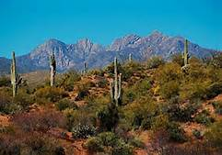
The Tonto National Forest is directly adjacent to the Phoenix metropolitan area and is one of the most heavily visited in the nation. From the desert to the tall timber, the Tonto National Forest contains a spectacular 2.9 million acres of cactus, chaparral, woodland, ponderosa pine, and mixed conifer country north and east of Phoenix right up to the edge of the Mogollon Rim. The Forest is the fifth largest in the United States and has six ranger districts operating in a complex, politically sensitive atmosphere. The Forest receives national attention concerning such issues as minerals management, recreation, range management, prescribed fire, road management, timber management and a host of issues related to the wild land urban interface next to the Phoenix metropolitan area.

Tonto National Forest Info: http://www.fs.usda.gov/tonto/

Globe Ranger District:

The Globe Ranger District is one of six districts on the Tonto and is located in the southeastern part of the Forest. The Globe District encompasses a gross area of 473,400 acres, including approximately 22,400 acres of private land within its boundaries and extends into three counties. In addition, the district includes parts of two wilderness areas: the popular Superstition Wilderness, and the pristine Salt River Canyon Wilderness. The district ranges from a low elevation of 2,400 feet to a high of 8,000 feet and climatic zones range from Sonoran Desert to Alpine. Topography is harsh and broken with approximately 336,993 acres of District lying on slopes of 20% or greater, and 110,650 acres of that is on slopes of 40% or greater. Much of the steeper country is inaccessible by vehicles and tends to have great accumulations of volatile fuels.

The district office is located in Globe, population 11,000. Globe is approximately 70 miles east of Phoenix, Mesa, Tempe metropolitan area (commonly known as the Valley) where there is limitless shopping and entertainment available; also, Globe lies about 100 miles north of Tucson, Arizona. Some of the Globe District employees live in the east Valley and commute daily. Local community services include public schools with grades K-12, a hospital, a limited service airport, public library, city parks, a variety of churches, local police and fire protection, two golf courses, and an ample business community.

Tonto Basin Ranger District:

Tonto Basin Ranger District lies between the Mazatzal and Sierra Ancha mountain ranges in central Arizona approximately 50 air miles east of the Phoenix metropolitan area. The district encompasses over 600,000 acres of National Forest lands and 7,787 acres of private lands. It includes Theodore Roosevelt and Apache Lakes, 2 of 6 man-made reservoirs in the Salt and Verde River chain of lakes, all of which are within the Forest boundary. Roosevelt is the largest lake entirely within the State of Arizona. Topography varies from broad mesas and foothills at the 2,500 feet level to mountains that range up to 7,657 feet at Four Peaks within the Mazatzals. Main travel routes through the district are the Apache Trail Scenic Byway (State Highway 88), State Highway 188 in Tonto Basin and the Young Highway (State Highway 288), which forms part of From the Desert to Tall Pines Scenic Byway.

The ranger station is housed at the Roosevelt Lake Visitor Center. This facility is located 35 miles northwest of the town of Globe and is approximately 50 miles southeast of the town of Payson. The Globe/Miami area and Payson both have year-round populations of approximately 10,000 to 11,000 people and are the nearest communities with full services.

The U.S. Department of Agriculture (USDA) prohibits discrimination on all its programs and activities on the basis of race, color, national origin, gender, religion, age, disability, political beliefs, sexual orientation, and marital or family status. (Not all prohibited bases apply to all programs.) Persons with disabilities who require alternative means for communication of program information (Braille, large print, audiotape, etc.) should contact USDA's TARGET Center at (202) 720-2600 (voice and TDD). To file a complaint of discrimination, write USDA, Director, Office of Civil Rights, Room 326-W, Whitten Building, 14th and Independence Avenue SW, Washington, DC 20250-9410 or call (202) 720-5964 (voice and TDD). USDA is an equal opportunity provider and employer.

