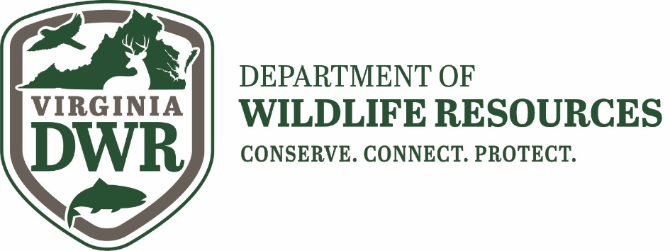

SEASONAL WATERFOWL TECHNICIANS
The Virginia Department of Wildlife Resources is hiring two technicians to assist the migratory game bird program during the upcoming fall and winter field seasons. Positions will begin in early November and end in April, exact dates are flexible. One position is eligible for extension to full-time wage employment (1500 hours per year). Primary duties are to assist with winter waterfowl trapping and banding. Other duties include fall productivity surveys for tundra swans and sea ducks, wood duck box monitoring, equipment maintenance, data entry, and assistance with other migratory game bird research activities as needed.
Applicants must be able to lift 50 pounds and have a valid driver’s license. Candidates with experience capturing and banding waterfowl preferred. Candidates should be self-motivated and able to work independently without daily direct supervision. Preference given to candidates with boating safety certificates and experience operating and towing boats.
State vehicle is provided for fieldwork. Housing is available at a nominal fee if needed. Variable hours including early mornings, nights and weekends during peaks of fieldwork. Overnight travel is frequently required for which lodging and per diem costs are reimbursed.
Normally 40 hours per week, $13.50 per hour. Primary work area is in eastern Virginia.
Position is open until suitable candidates are found. E-mail resume and three references with contact information ASAP to: Ben Lewis, Benjamin.Lewis@dwr.virginia.gov

