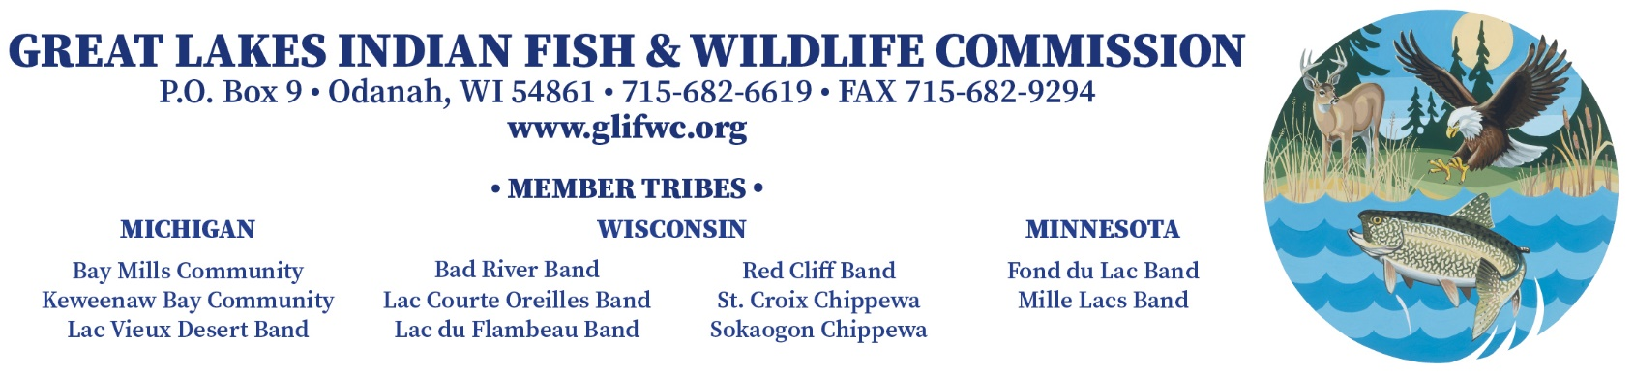

JOB ANNOUNCEMENT

POSITION: Fisheries Aide - Spring 2022

WAGES:

$15.00 per hour - 1st - 4th year
$16.00 per hour - 5th - 10th year
$17.00 per hour - 10th year +

CONDITIONS OF EMPLOYMENT: This is a temporary, part-time position. Dates of employment are not fixed but will run approximately 2-3 weeks after the ice goes out on inland waters.

SUPERVISION: Reports to GLIFWC Inland Fisheries Biologist or designee.

DUTIES & RESPONSIBILITIES: Assist with electrofishing surveys (typically at night) or fyke net surveys of adult walleye in ceded territory lakes and perhaps rivers. Persons will help launch and operate boats, dip fish, and collect biological information. Ability to travel for up to 3 consecutive weeks is required. Overnight lodging, per diem, and mileage will be paid. Must be willing to share overnight lodging accommodations with co-workers.

QUALIFICATIONS: Ability to identify gamefish and panfish. Persons will be expected to follow safety guidelines, to collect information in an efficient manner, and to record data neatly and accurately. Vehicle and driver's license preferred but not required. All applicants will be considered but Indian preference will be given if all other qualifications are equal. Also, preference given to persons with previous GLIFWC employment.

TO APPLY: Send GLIFWC or tribal application form to:

Mark Luehring
GLIFWC
P.O. Box 9
Odanah, WI 54861

Persons who have submitted an application for this position in the past need not send another application. However, these persons must call or write a letter stating their interest in the position.

CLOSING DATE: Wednesday, March 15, 2022, or until filled.

