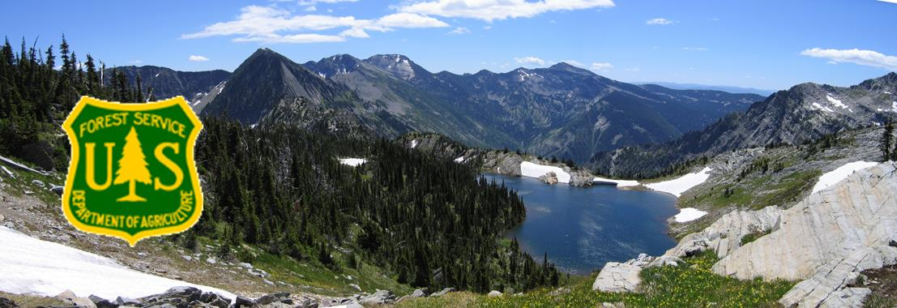

OUTREACH
Kootenai National Forest
Engineering
Civil Engineer, GS-810-7/9

The Northern Region (R1) may soon be filling two, Civil Engineer (Project Engineer), GS-7/9 positions located on the Kootenai National Forest. One position is located in Eureka, MT. and the other located in Libby, MT. The forest is seeking interested applicants (internal federal government and external) and through the Pathways Recent Grad program. This is a permanent full time position and if filled through the Pathways program, incumbent may be placed at a different location

Interested Forest Service applicants may access this outreach through Employment Outreaches located in ConnectHR/Dashboard and respond via email within the database.

Interested external, including Pathways, applicants may access via internet search utilizing fs outreach or https://fsoutreach.gdcii.com/. This will bring you to a search screen to enter various data to access the outreach. Once outreach is located, you may then respond within the Outreach database.

Duties:
This position serves as the Civil Engineer with responsibilities of Timber Sales (TS), Public Works (PW) Construction Contracts, design and other duties.

Experience as an Engineering Representative (ER), Contracting Officer’s Representative (COR) and/or Inspector for TS/PW is highly desired. As COR or ER, incumbent will interpret plans and specifications relating to problems where precedents exist or those without unusual complications. Monitor all aspects of Contractor activities to assure compliance with contracts on entire projects of limited size or complexity or a minor part of a large project such as roads, bridges, parking facilities, trails, drainage structures, erosion control features, retaining walls, buildings, towers, equipment shops and yards and recreation sites.

Apply knowledge of contract law, acquisition regulations, contracting procedures and technical aspects such as materials, installation, and construction techniques to ensure contractor performance conforms to contract requirements and to resolve problems that arise during construction.
Evaluate and interpret plans and specifications relating to problems where precedents exist or those without unusual complications.

Develop project plans and specifications for contract advertisement, ensure compliance with environmental requirements and determine practicability from a construction standpoint.
Incumbent will participate in pre-construction meetings to resolve construction problems that may be of unusual difficulty and complexity. Oversee detailed site survey and stake setting. Investigates foundation and borrow pits. Incumbent will review specifications for clearing of land, excavation, building access roads and utilities.

Incumbent will inform contractor of requirements for progress reporting, safety, wage and hour law observance, labor relations and payroll records. Oversees inspections and interprets plan and specifications. Investigate the need for contract change orders, considering conditions at work site, field measurements and computations, local prices and negotiates cost for required changes and make recommendations to the Contracting Officer for final authorization.

Incumbent will develop and modify civil engineering plans and specifications for new construction. Maintain data in the corporate database required for upward reporting and planning purposes.

For more information regarding this position, please contact Pamela Baltz 406/296-7175 pbaltz@fs.fed.us for the position in Eureka and Nate Marcoe 406/283-7589 nmarcoe@fs.fed.us for the position in Libby.

ABOUT THE FOREST
The Kootenai National Forest is located in the extreme northwest corner of Montana, a small portion of northeast Idaho and encompasses over 2.2 million acres of NFS lands, an area nearly three times the size of Rhode Island. The forest consists of 4 Ranger Districts located in Eureka, Troy, Libby and Trout Creek; 3 Staff Units located in the Supervisor’s Office and Engineering located throughout the units. The Forest is bordered on the north by British Columbia, Canada, and on the west by Idaho. Of the total acres, 50,384 are within the State of Idaho. Access into the Forest is via U.S. Highways 2 and 93 and Montana State Highways 37, 56, 200 and 508.
Ranges of high craggy peaks mark the Forest with Snowshoe Peak in the Cabinet Mountains at 8,738 feet, the highest point. The Whitefish Range, Purcell Mountains, Salish Mountains, and Cabinet Mountains are all part of the rugged terrain radiating from the river valleys. In the north central part of the Forest, the land is more open with gently rolling timbered hills lying in the shadows of the Whitefish Range.
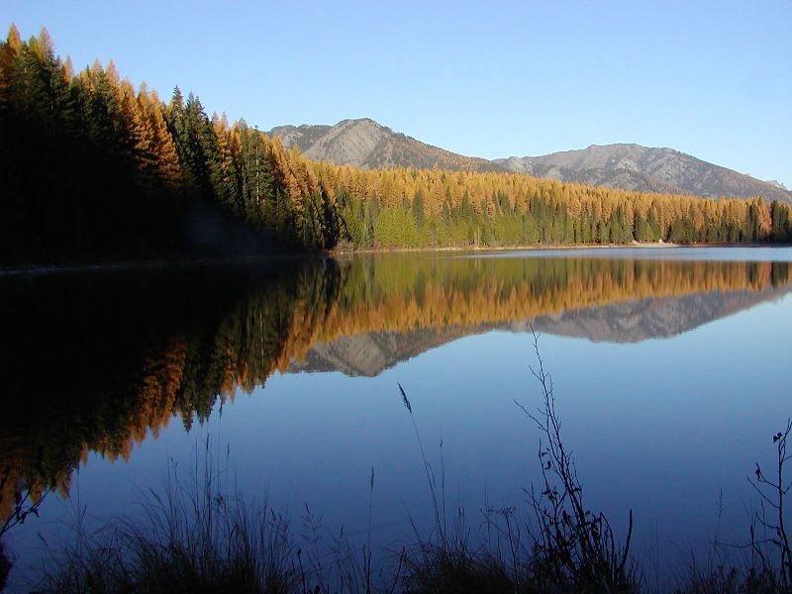
The Forest is dominated by two major rivers, the Kootenai and the Clark Fork, along with several smaller rivers and their tributaries. Two hydroelectric dams on the Clark Fork have created the Cabinet Gorge and Noxon reservoirs within the Forest boundary. State Highway 200 parallels these reservoirs as it crosses the Forest.
The Kootenai River is spanned by another hydroelectric (and flood-control) project, Libby Dam.

This structure located about 17 miles upstream from Libby, Montana, created Lake Koocanusa, a 90-mile-long reservoir reaching northward into the Canadian Rockies. Lake Koocanusa is almost totally surrounded by national forest lands, no private summer home or condominium developments here. State Highway 37 follows the east shore to Rexford and beyond to Eureka, Montana. The elevation of the Kootenai River as it leaves the Forest and the State is 1,862 feet, the lowest point in Montana.

The Yaak, Fisher, Tobacco, and Vermillion Rivers are smaller rivers within the confines of the Forest. There are over 100 lakes inside the boundaries of the Kootenai ranging from small alpine lakes to 1,240 acre McGregor Lake.
The climate of the Kootenai has been described as "modified Pacific maritime" in character, meaning that compared to the remainder of Montana, this area's climate resembles that found along the Pacific coast. The character becomes "modified" by occasional intrusions of the arctic air masses, more commonly found in the remainder of the State, which can bring winter temperatures down to -30° F with heavy snowfalls in the mountains. Average annual temperatures of 45° F reflect the moderating influence of the Pacific air masses. Summer temperatures are moderate with few days reaching over the 100° mark. The wet season in the Forest usually occurs in the fall and early winter.

The Kootenai is truly a forest with multiple uses. The vegetation management program is aimed at restoring and maintaining Northern Rockies fire dependent habitats. The diversity of tree and other plant species is among the greatest in the Northwest. Management and recovery of threatened and endangered species, such as grizzly bear, lynx, and bull trout emphasize the forest wildlife and fisheries programs. Other wildlife on the forest include gray wolf, wolverine, cougar, elk, moose, white-tailed and mule deer, mountain goat, bighorn sheep, bald and golden eagles and other species of birds, mammals, amphibians, and reptiles.

INDIAN TRIBES
The Kootenai National Forest (KNF) encompasses lands that are part of the Confederated Salish and Kootenai Tribes (CSKT) Aboriginal Territory. In the Hell Gate Treaty of 1855 the CSKT ceded over 22 million acres to the United States Government retaining 1.2 million acres for their own use that today is the Flathead Indian Reservation. The Flathead Indian Reservation is approximately 85 miles southeast of the Kootenai National Forest. The Tribes retain Treaty rights under the Hell Gate Treaty on federal lands such as the KNF. These rights include hunting, gathering, digging plants and roots, fishing, and grazing on Kootenai National Forest lands.

The Kootenai National Forest holds many places in the natural environment that are important to the Kootenai people. These are known as cultural sites and traditional cultural properties. The relationship and bonds that Kootenai people have to these places were established before there was a Kootenai National Forest and the stories, place names and songs from these sites have been handed down from generation to generation. This is called a cultural landscape and is the basis for or essence of Kootenai identity and culture.

ABOUT THE DISTRICT and COMMUNITY
The Ksanka Ranger District (Rexford and Fortine Ranger Districts are in the process of combining) is located in Northwest Montana. The duty station is Eureka, MT which is located just eight miles from the Canadian border. The District’s entire northern boundary is contiguous with Canada, and it is one of the four districts on the Kootenai National Forest. The District encompasses 701,500 acres, of which 558,000 are National Forest lands. The district employs approximately 40 permanent employees, with an additional 50-60 seasonal employees during the summer months.

The town of Eureka has a population of approximately 1300 people and is the largest town in the Tobacco Valley. Residents in the Tobacco Valley number approximately 4200. The Valley runs from the Canadian Border on the north to just south of Murphy Lake. The major industry is timber, with recreation, in the form of hunting, fishing and winter sports, drawing in a number of tourists. Employees generally live in the Valley and some commute daily from the Whitefish area. Eureka offers a post office, three banks, three grocery stores, two medical clinics, one dentist, three chiropractors, a physical therapist, one drug store, 2 motels, a bed & breakfast, a number of masseuses, an optometrist, several second-hand stores, numerous small variety shops, restaurants, three golf courses, and businesses. Churches of various denominations are also available in the area.

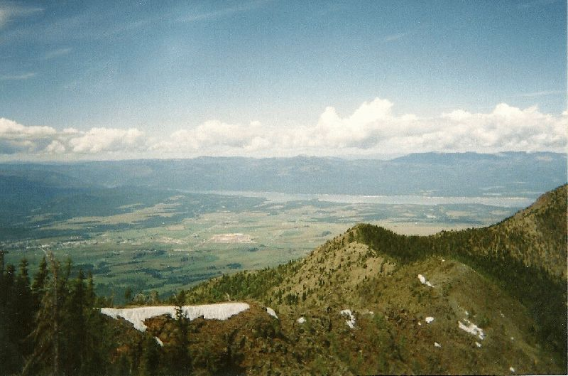
In Eureka there is an elementary school, which includes K-4, a middle School (5-8), and the Lincoln County High School. A Head Start program is also available.
The larger communities of Whitefish (50 miles) and Kalispell (65 miles) offer a wide variety of shopping and other service-oriented businesses. Eureka is approximately five hours from Spokane, Washington (population 342,000), and four hours from Missoula (population 33,400). Glacier Park International Airport near Kalispell provides daily departures and an AMTRAK station is available in Whitefish. Glacier National Park to the east and Banff National Park in Canada are also close enough to be enjoyed for the day or weekend.

Eureka has both mild winters and summers compared to other Montana cities. The District includes the popular Lake Koocanusa Reservoir, beautiful mountains and many surrounding fresh water lakes. There are many recreational opportunities, such as swimming, water skiing, camping, rock climbing, fishing and hiking for summertime fun; hunting in the fall and spring; ice fishing, snowmobiling and cross country skiing in the winter; and ATV and motorcycle riding on Lake Koocanusa reservoir draw down area in the spring. Eureka is just 60 miles north of the Whitefish Mountain Resort Ski Area in Whitefish and 35 miles south of the Fernie Ski Area in Canada. Average rainfall for the area is 14.6” and the average snowfall is 44.4”.

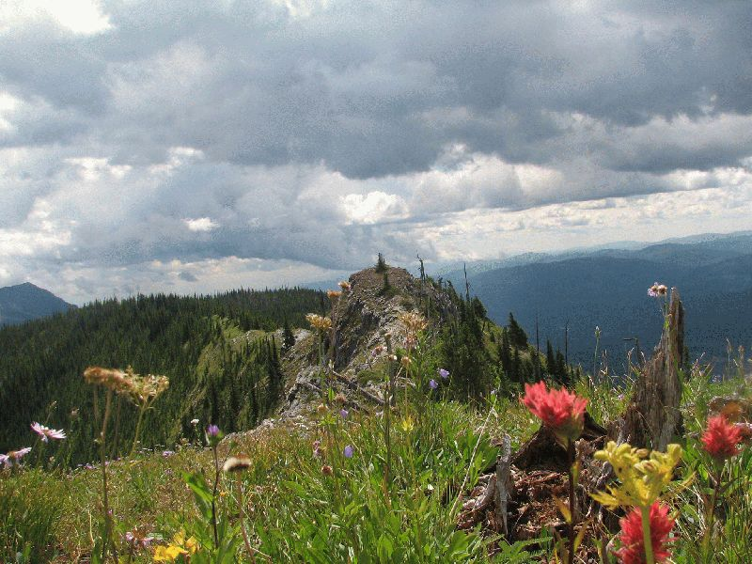
Located 15 miles south of Eureka is the community of Fortine. The Fortine community has a school (Grades preschool-8), post office, grocery store, church, golf course and bar.

The community of Trego is located approximately 18 miles south of Eureka and offers a Civic Center, Post Office and school (Grades K-8).

Housing prices are moderate in the Tobacco Valley. A three-bedroom home sells for $100,000-$400,000. Rentals are scarce, but can be found. Government housing may be available.

Gardening opportunities vary depending on where you live in the Valley, those closer to Eureka usually have a bit longer season than those farther south.

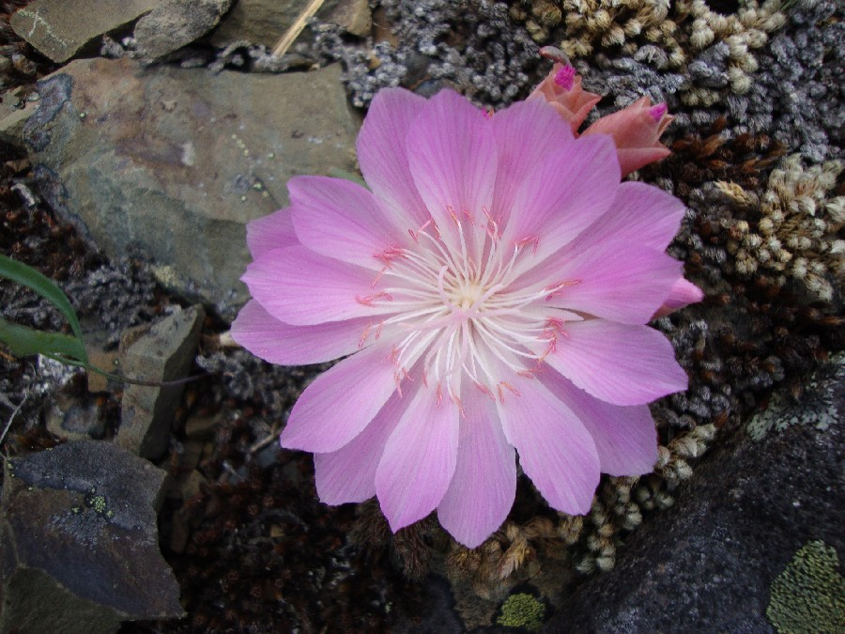
ABOUT THE COMMUNITY
Libby lies in the northwest
corner of Montana and is nestled
in a valley carved by the Kootenai River on the flank of
the majestic Cabinet Mountain
Range and Wilderness Area.
Today, about 2,800 people live
within Libby proper. The main industries are lumber and wood products, mining, tourism, and recreation. The movies "The
River Wild" and "Always" were
filmed here. Contact the Libby Chamber of Commerce for brochures, information on lodging and events, general area information, and contact information for local businesses and services.

The Libby Ranger District operates out of the Canoe Gulch Ranger Station located in Libby, Montana. The Ranger Station is located along the Kootenai River, 13 miles from Libby, Montana.

Libby, Montana is basically a full service community providing education from K through 12th grade, a medical clinic, several stores, bank and credit union and a bowling alley. Libby also has an excellent city park.

Glacier National Park is 115 miles to the east and Spokane, Washington is 150 miles to the west. For more information on Libby go to www.cityoflibby.com

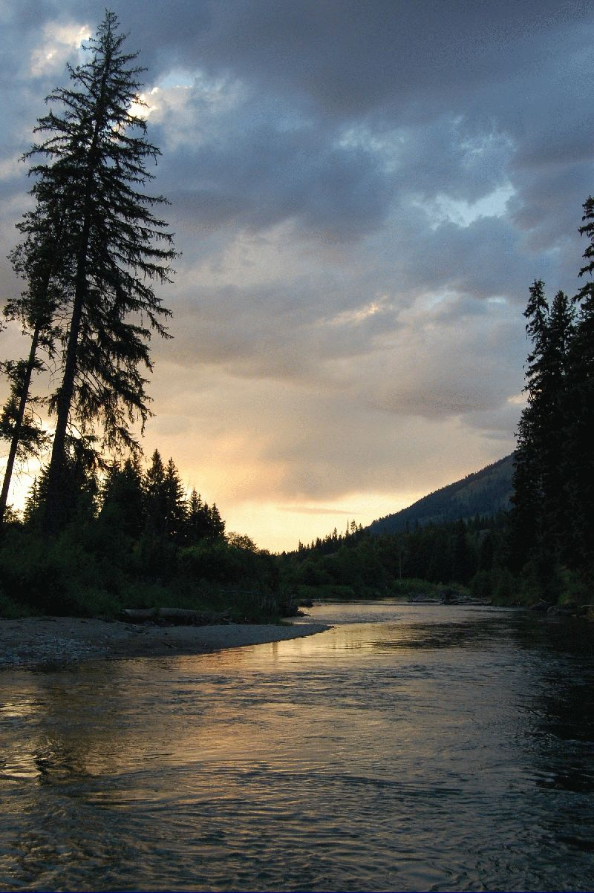
The Libby Ranger District encompasses 620,000 acres. Libby has a strong resource management program with heavy workloads in vegetation management, fire, wildlife, recreation and watershed restoration. During the peak of the summer, there are approximately 35 permanent employees and a temporary work force of approximately 60 working on the District.

The Libby valley has documented presence of Libby Amphibole as determined by the Environmental Protection Agency. Interested applicants are urged to be aware of and research the possible hazards of amphibole to human health. Cleanup and hazard mitigation operations are being conducted by the EPA. Please contact the EPA (http://epa.gov/region8/superfund/libby/), the CARD (Center for Asbestos Related Disease: http://www.libbyasbestos.org/), or District Rangers for more information.

Additionally, Libby Ranger District encompasses an area identified as Operable Unit 3 (OU3) as determined by the EPA. OU3 contains the old mine site and immediate surrounding area and is approximately 38,000 acres. This area presents special resource management concerns due to the established presence and concentration of asbestos fibers in the tree bark and duff. Management protocols have been established and continue to be developed for resource management and to provide for employee and public safety, specifically ground-disturbing activity and wildland firefighting. Work is ongoing for the nature and extent of contamination and hazard levels in conjunction with the EPA.
SUMMER
When the weather warms and the mountain snows melt away, the Kootenai National Forest comes alive with over 2.2 million acres of public land as a playground. Mountain trails and lakes open up, beautiful wildflowers come in bloom, and wildlife have their young. Libby is the base camp for the Cabinet Mountains Wilderness Area, Lake Koocanusa, Northwest Peaks Scenic Area, and the Ten Lakes Scenic Area. There is good access to most of the Forest and plenty of room to get away from it all!
- Blue ribbon fishing in the Kootenai River
- Cabinet Wilderness Area hiking and exploring
- 90-mile long Lake Koocanusa Reservoir
- Camping in dispersed and developed campgrounds
- Miles of hiking, backpacking & mountain biking trails
- 2.2 million acres to play on the Kootenai National Forest
- Boating on the Kootenai, Lake Koocanusa, and numerous area lakes
- Golfing at Cabinet View Country Club Golf Course

FALL
Northwest Montana, the Kootenai National Forest, and adjacent State of Montana and private lands have abundant wildlife. In Montana, hunting is primarily a family sport. There are general seasons for elk, deer (white tail and mule deer), and bear. There are annual drawings for permits to hunt moose, bighorn sheep, mountain goat, and mountain lion. For bird hunters there are turkey, grouse, and some ducks. For more information: Hunting - Montana Fish, Wildlife & Parks
WINTER
Winter in Montana means snow, and lots of it! For those who love to play in the deep powder, the Libby area offers tremendous winter fun. Turner Mountain Ski Area, located just 22 miles from Libby, offers challenging downhill skiing with a beautiful view. Their slogan is "steep, deep and cheap", and Turner definitely lives up to that. It's still fairly undiscovered, so you can escape the crowds and get the cheapest lift tickets around. For those who love snowmobiling, there are hundreds of miles of backcountry roads to sled on in the Kootenai National Forest. Cross-country skiers and ice fishermen also can find solitude on a lake and miles of quiet forest trails to enjoy the outdoors. Those who are a bit on the wild and crazy side will love the antics of the Libby Polar Bear Club. Members take winter-time "swims" in frigid Libby Creek every Sunday from October to April. Plungers have ranged in age from 3 to 61. As long as the ice can be broken on the creek, if it has formed, the group will take their plunge, no matter the temperature. LibbyMT.com

