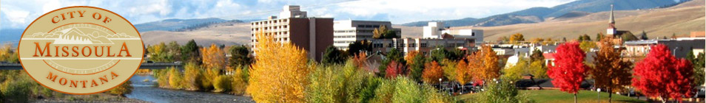

***Outreach Notice***

**Regional NRM (Infra) Coordinator**

**GS – 0801/0301/1301 – 11/12, Northern Region, Missoula, MT**

**INTRODUCTION:**

The Northern Region is conducting outreach for its Regional NRM (Infra) Coordinator position, located in the Regional Office in Missoula, MT.

**MAJOR DUTIES:**

The position serves as the person responsible for providing leadership and assistance by disseminating new information, troubleshooting database problems, and facilitating data collection from the field in a timely manner. Serves as WO point of contact for the Region and represents the Region in national coordination of the Infra database management. Write ad-hoc, customized reports to extract specific information on and as needed basis. Provide Corporate Data Warehouse reports for performance reporting, strategic planning, and Congressional inquiries.

Participate in planning conferences with supervisors and data stewards to provide necessary information pertaining to corporate data management. Reviews and provides input to proposed, new, or revised national policy directives. Develops and distributes standards and guidelines for implementation and compliance by subordinate units.

Manage new NRM Infra profile requests, expiring profiles, process profile changes or updates, and do monthly users renewals for approximately 20 Infra modules.

**[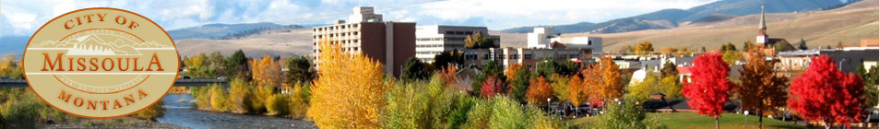](http://www.ci.missoula.mt.us/)**

**THE COMMUNITY:**

Missoula, Montana draws people from diverse backgrounds. Missoula is nestled in the Rocky Mountains of western Montana. This scenic city is bustling with activity, as western Montana's regional source for business, culture, medical services, retail, and entertainment. There are endless opportunities for fishing, thousands of miles of trails, and plenty of guides and shops to clue you in on the hot spots. With an area population of more than 70,000, Missoula has what you'd expect to find in a big city--a wide range of hotels, restaurants, shops and galleries, several museums, a ballet company, live theater and a symphony. It's also home to The University of Montana, laid-back coffee houses, historic bars and cozy bookstores. As a natural outdoor playground it's unparalleled, and yet Missoula is one of the most dynamic cultural centers in the Northwest. Missoula is a major retail and medical hub in Western Montana and claims one of the nation's highest doctors to patient ratios. A wide variety of specialty, discount, and budget shopping centers make Missoula the retail hub for an estimated 200-mile radius. The Missoula school system is considered excellent with three public and two private high schools, numerous elementary schools, a College of Technology and the University of Montana.

Missoula serves a trade area in excess of 300,000 and therefore, has more amenities and services than most cities of its size. The foundations of Missoula's economic base are wood and paper products, Federal Government, motor carriers and the University. There is a great diversity of neighborhoods and residential settings within the community and surrounding area ranging from urban to very rural.

There are an abundance of recreation facilities and opportunities located in and around the Missoula area. These include: public golf courses, parks, tennis courts, swimming pools, health clubs, racquetball courts, YMCA, softball diamonds, hiking trails, ice skating rink. There are many rivers in the area for rafting, fishing and swimming. Snowbowl ski area is less than an hour's drive from town and within a two-hour drive are Discovery, Lost Trail and Lookout Pass. Also close to Missoula are numerous cross country ski trails, and snowmobile trails.

Missoula has two large hospitals, which provide a full array of inpatient and outpatient services. Missoula has many other health care practitioners to offer.

Missoula residents enjoy all four seasons of the year. The elevation is 3,205, with an average annual temperature of 45 F, with a January daily minimum of 15.5 F. and July daily maximum of 83.4 F. The growing season averages 137 days, an average mean rainfall of 13.5 inches, and an average mean snowfall of 42.5 inches.

Montana has personal income tax and property tax, but NO sales tax.

**Additional Information:** If you would like additional information about the city of Missoula, you can contact the Missoula Chamber of Commerce at (406) 543-6623. Extensive additional information on the Missoula area can be found on the internet at http://www.missoula.com.

For more information, please contact Fred Bower, Transportation Group Leader at 406-329-33354. If you are interested in the position, please complete the attached Position Outreach Interest Response Form, along with a brief resume, and email to [fbower@fs.fed.us](mailto:fbower@fs.fed.us) by October 26, 2015.





OUTREACH RESPONSE FORM

**Regional NRM (Infra) Coordinator**

**GS – 0801/0301/1301 – 11/12, Northern Region, Missoula, MT**

Please submit outreach response, along with a brief resume to Fred Bower [fbower@fs.fed.us](mailto:fbower@fs.fed.us)

by October 26, 2015. Thank you for your interest.

|  |
| --- |
|  |

NAME:

|  |
| --- |
|  |

E-MAIL ADDRESS:

|  |
| --- |
|  |

MAILING ADDRESS:

|  |
| --- |
|  |

TELEPHONE NUMBER:

|  |  |  |  |  |  |
| --- | --- | --- | --- | --- | --- |
|  | {USFS |  | {BLM |  | {OTHER |

AGENCY EMPLOYED WITH:

|  |  |  |  |  |  |
| --- | --- | --- | --- | --- | --- |
|  | {PERMANENT |  | {TEMPORARY |  | {TERM |

TYPE OF APPOINTMENT:

|  |  |  |  |  |  |
| --- | --- | --- | --- | --- | --- |
|  | {VRA |  | {PWD |  | {OTHER |

|  |  |  |  |
| --- | --- | --- | --- |
|  | {REGION |  | {FOREST |

CURRENT:

|  |  |
| --- | --- |
|  | {DISTRICT |

|  |  |  |  |
| --- | --- | --- | --- |
|  | {SERIES |  | {GRADE |

CURRENT:

|  |  |
| --- | --- |
|  | {POSITION TITLE |

CURRENT:

HOW DID YOU FIND OUT ABOUT THIS OUTREACH NOTICE?

|  |
| --- |
|  |

IF NOT A CURRENT PERMANENT (CAREER OR CAREER CONDITIONAL) EMPLOYEE

ARE YOU ELIGIBLE TO BE HIRED UNDER ANY OF THE FOLLOWING SPECIAL AUTHORITIES:

|  |
| --- |
|  |

PERSON WITH DISABILITIES

|  |
| --- |
|  |

VETERANS RECRUITMENT ACT

|  |
| --- |
|  |

DISABLED VETERANS W/30% COMPENSABLE DISABILITY

|  |
| --- |
|  |

VETERANS EMPLOYMENT OPPORTUNITIES ACT OF 1998

|  |
| --- |
|  |

FORMER PEACE CORPS VOLUNTEER

|  |
| --- |
|  |

PATHWAYS PROGRAM