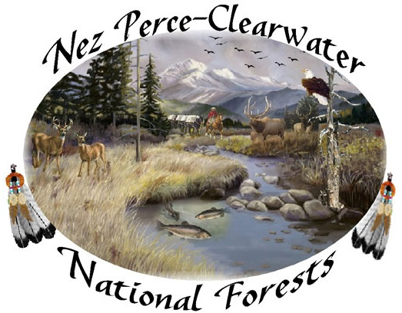

**NEPA Planner- North Zone Team Leader**

**Nez Perce - Clearwater National Forests**

**Series:** GS-0101/0401

**Grade:** GS-11

**Appointment:** Permanent Full-time

**Duty Location**: North Fork District, Nez Perce-Clearwater National Forest, Orofino, Idaho

**Primary Contact:** Norma Staaf, Forest Environmental Coordinator, office phone- 208-935-4284, cell phone- 208-935-4284 or [nstaaf@fs.fed.us](mailto:nstaaf@fs.fed.us).

**Interested Candidates:** Please complete the **Outreach Interest Form on the last page and return by December 1, 2015**. This information allows us to determine the type and length of vacancy announcement needed. It also ensures that interested people will receive the vacancy announcement as soon as it is posted. We may consider advertising as a demo (open to the public) in addition to merit if we hear from qualified candidates early in the outreach process. You are encouraged to submit a brief 1-2 page resume that outlines your knowledge and experience with leading interdisciplinary NEPA teams.

**The Position**

The North Zone Team leader serves as interdisciplinary team leader for a variety of projects on the Forest including but not limited to, timber, range, and watershed restoration projects. This includes providing direction to the team during the NEPA process. The team leader takes the lead on public scoping, identification of issues, development of alternatives and making recommendations to the responsible official (district ranger and forest supervisor). The team leader presents the projects at meetings with the Nez Perce Tribe, regulatory agencies and collaborative groups. The north zone team leader is supervised by the forest environmental coordinator and works with two district rangers and a shared interdisciplinary team that is known for working well together to complete NEPA projects on a fast-paced, results-oriented Forest.

**The Forest**

The Nez Perce-Clearwater National Forests includes 4.0 million acres of beautiful and diverse landscapes, located in North Central Idaho. These range from the dry, rugged canyons of the Salmon River to the moist cedar forests of the Selway drainage to the rolling uplands of the Palouse.

The Forest has taken a strong approach to accomplishing the Chief’s accelerated restoration emphasis. This is particularly true with the vegetation management program where we have accelerated the annual volume sold from 40 to 60 MMBF. The Forest has a long-established partnership with the Nez Perce Tribal staff to jointly complete NEPA and implement extensive aquatic watershed restoration projects on the Forest.

Information on the Nez Perce-Clearwater National Forests can be found at:

<http://www.fs.usda.gov/nezperceclearwater>

**The Community**

Orofino, Idaho is located on north bank of the Clearwater River. It is the county seat of Clearwater County with approximately 3,000 residents. The nearby Clearwater, Lochsa, Selway and Salmon Rivers offer white water rafting, scenic floating and fishing. Rivers range from highly technical, remote wilderness rivers to easily accessible broad rivers. Hunting opportunities for elk, deer, bear, mountain lion, pheasant, turkeys and grouse are available.

Information on the community of Orofino, Idaho can be found at:

<http://www.orofino.com/index.php/>

https://en.wikipedia.org/wiki/Orofino,_Idaho

**Outreach Response Form- NEPA Planner**

**Nez Perce-Clearwater National Forests**

Position/Title/Series/Grade: Social Scientist / Biological Scientist, GS-0101/0401-11

Duty Station: Nez Perce-Clearwater National Forests

Orofino, Idaho

If you are interested in this position and would like us to send you the vacancy announcement, please complete this form and return to Norma Staaf at:

Email: [nstaaf@fs.fed.us](mailto:nstaaf@fs.fed.us)

Phone: (208) 935-4284

Hardcopy: Nez Perce-Clearwater National Forests

Forest Supervisor’s Office

Attn: Norma Staaf

903 3rd Street

Kamiah, Idaho 83536

|  |  |
| --- | --- |
| **Name** |  |
| **Address** |  |
| **Phone #** |  |
| **Email** |  |
| **Are you currently a Federal Employee?** |  |
| **Current Title/Series/Grade** |  |
| **Current Duty Location** |  |
| **Type of Current Appt. (Permanent, term, temporary)** |  |
| **Current Employment Status (career conditional, Excepted, VRA, Peace Corps etc.)** |  |