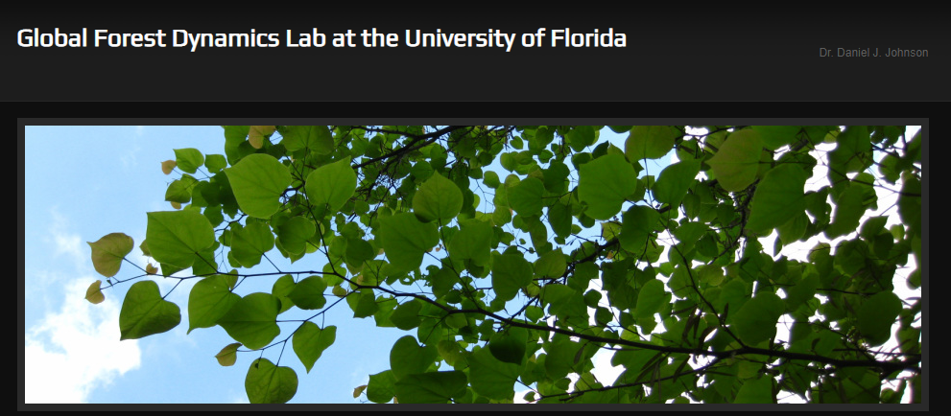

We are hiring several forest research technicians for the coming summer. Please share as widely as possible.

1. ForestGEO recensus (Indiana):
https://go.ufl.edu/ma0c0tc
We are hiring four crew members to work on the third census of the Lilly Dickey Woods plot in southern Indiana.

All positions pay $15/hour and expected to run from early May to late July.

2. Macrosystems Forest Health surveys (multiple locations):
https://go.ufl.edu/edm0tro
We are hiring four crew members to collect annual forest health data on two ForestGEO plots (SERC and Harvard Forest).

All positions pay $15/hour and will run from Late June to the end of July.

Contact Dan Johnson (johnson.daniel@ufl.edu) with questions.

