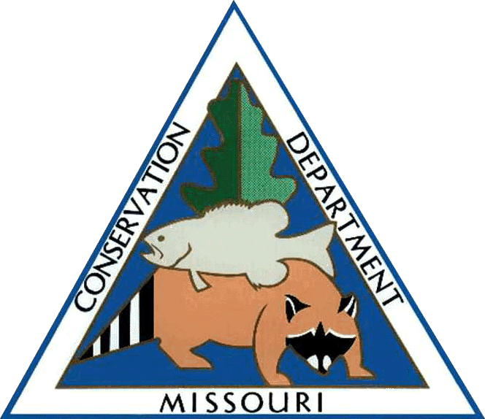

MISSOURI DEPARTMENT OF CONSERVATION
FULL TIME HOURLY JOB OPPORTUNITY

Region: Central
Official Domain: Central Office, Jefferson City
Title: Assistant Wildlife Diversity Coordinator

Pay Rate: $20.43/hr
Starting Date: May 2, 2022
Hours: up to 40 hours per week*

Supervisor: Kelly Rezac, Wildlife Diversity Coordinator, Missouri Department of Conservation

Duties:
This position will assist the Wildlife Diversity Coordinator in management of the Wildlife Diversity Program and Endangered Species Program. Primary responsibility will be to lead implementation of the Missouri Department of Conservation’s (MDC) Bat Habitat Conservation Plan (HCP) in coordination with the HCP Implementation Team. The Bat HCP, finalized in February 2022, is a comprehensive plan developed in coordination with the U.S. Fish and Wildlife Service (FWS) to ensure that MDC’s habitat management and infrastructure maintenance and development activities comply with the Endangered Species Act by minimizing potential impacts to listed bats, and to support the recovery of threatened, endangered, and declining bat populations in Missouri. This position will be responsible for leading and coordinating development of many of the components of the HCP including:
- Develop a template for the annual report and use it to prepare the annual report
- Summarize and analyze spatial data for inclusion in the annual report and for monitoring HCP related activities
- Develop an HCP Communication Plan and associated public outreach
- Develop and maintain the HCP web page on the MDC website
- Coordinate development of management plans for Priority Bat Management Zones (PBMZs) in coordination with the Bat Ecologist and District Supervisors
- Manage the cave buffer and cave gate monitoring plan by creating a rotational schedule for surveying the condition of cave buffers and cave gates, coordinating with the Bat Ecologist and regional staff to ensure all surveys planned for a given year are completed, and managing data on the current condition of all cave buffers and cave gates including any actions recommended to improve conditions.
- Coordinate development of bat-friendly construction and demolition guidelines
- Coordinate development of guidelines for bat-friendly construction of roads, trails, and fire lines
- Coordinate update of White-nose Syndrome action plan
- Develop training materials including
  - How to recognize and avoid potential roost trees
  - Bat best management practices for professional timber harvesters
- Assist in developing and delivering HCP-related training programs to MDC staff, partners, and the public
- Assist with reviewing and updating HCP buffer and Priority Bat Management Zone maps in ArcMap

Provide scientific support. Assist with data entry, compilation, and organization of large quantities of data, and data analysis using Excel. Conduct literature reviews and summarize results.

Provide logistical and administrative support for planning team meetings, workshops, staff trainings, and events. Attend meetings, workshops, and events to provide on-site logistical and administrative support. Record detailed meeting notes and distribute to attendees. Assist with preparing, printing, and assembling meeting materials and supplying necessary equipment.

Qualifications:
Graduation from an accredited college or university with a Bachelor’s Degree in Wildlife Ecology, Wildlife Management, Biology, Zoology, Animal Ecology, Conservation Biology, or applicable field of study or equivalent related education and experience. Duties require the applicant to have project management/leadership experience; data management and analysis experience; experience developing written plans and reports; excellent verbal and written communication and coordination skills; team work; and a working knowledge of Missouri’s natural communities. Background in bat ecology especially endangered, threatened, and declining populations is highly preferred.

Knowledge of and ability to use ArcMap, Word, Excel, PowerPoint, and other software tools are necessary.

Candidates seeking initial employment or re-employment must submit to a drug screen following offer of employment.

*Disclaimer: Extension beyond June 30, 2023, is conditional upon budgetary constraints and approval of the Department’s FY24 budget, continued availability of funds, and employee performance.

Send resume and at least 3 references to:
Kelly Rezac
Missouri Department of Conservation
2901 W. Truman Blvd.
Jefferson City, MO 65102
573-522-4115 ext. 3151
Kelly.Rezac@mdc.mo.gov

Deadline for Applications: April 14, 2022

