Summer Undergraduate Plant Lab Technician
Agency
University of Illinois Urbana-Champaign
Location
Turner Hall, University of Illinois Urbana-Champaign
Job Category
Temporary/Seasonal Positions
Salary
$12/hour
Start Date
ASAP or Summer

Description
1 lab technician (10-15hrs/week) needed for the summer. Technicians will be assisting with plant trait measurements from plants collected in the Alaskan Tundra during the summer of 2021.
Duties of technicians are varied and will consist of a combination of the following: root extraction from soil cores, root trait measurements, and preparation of leaf and root samples for isotope analysis.
Please submit the following: CV, and contact information.
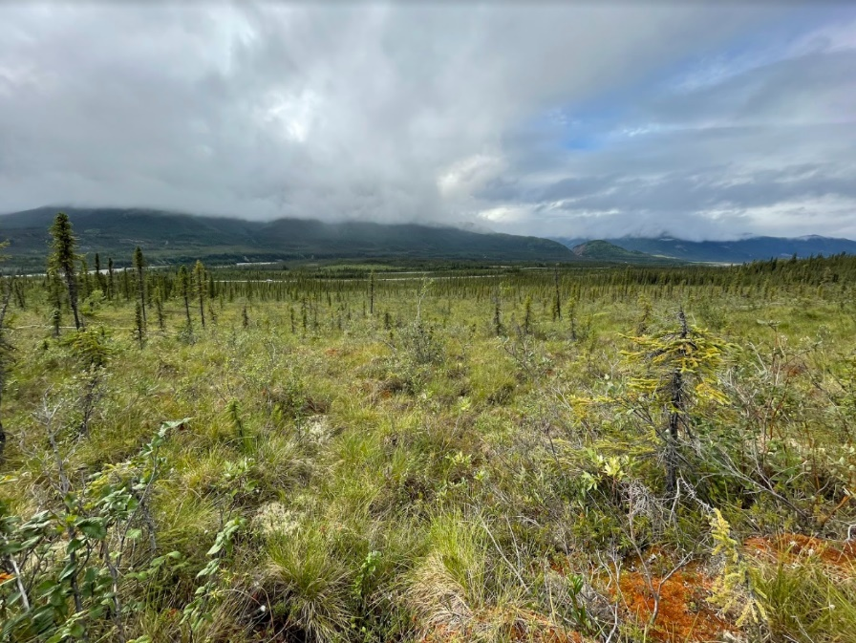
Qualifications
Required: UIUC undergraduate
Preferred: experience with root extraction
Contact Person:
Ilana Zeitzer
Contact Email:
Zeitzer2@illinois.edu

