USDA Forest Service | Eastern Region

Chippewa National Forest

OUTREACH NOTICE
Soil and Watershed Program Manager
GS 11/12 - 0470/1315
The USDA Forest Service, Eastern Region, Chippewa National Forest anticipates seeking a candidate for a Soil and Watershed Program Manager, GS 11/12 - 0470/1315. This will be a permanent, full time position. The purpose of this Outreach Notice is to inform prospective applicants of this upcoming opportunity. To express interest in this position, please complete the attached voluntary Outreach Interest Notice and return to Jim Gries at jgries@fs.fed.us by close of business on October 20, 2017.

Brief description of duties associated with this position:
The position will be located in Cass Lake, Minnesota at the Chippewa National Forest’s Supervisors office. The Soil and Watershed Program Manager will perform the following major duties:
- Develops and executes the unit soil and watershed program. Interprets and implements new or revised policy directives or program materials from higher authority or regulatory agencies; prepares reports on a variety of complex studies; formulates plans for local application; prepares budget proposals; and develops replies to technical watershed program information requests.

- Provides soils and hydrologic functional assistance and recommendations to managers and other resource specialist while carrying out planned management activities across all functional areas. This includes reviewing projects or activities on-the-ground to analyze soils or hydrologic impacts as a result of such activities.

- Assesses, classifies and monitors watershed conditions and trends. Leads watershed improvement program including facilitating watershed prioritization for restoration, developing watershed restoration action plans, and developing and tracking watershed improvements. Conducts and interprets soils and hydrologic surveys and analysis; watershed rehabilitation and management planning and execution; and provides technical guidance within the framework of multiple-use management of forest and range lands.

- Either individually or as part of an interdisciplinary team, develops and evaluates a variety of proposed actions from all functional areas to ensure technical and administrative quality and compliance with National Environmental Policy Act (NEPA) as well as directives related to the watershed program area. Conducts and interprets soils surveys and analysis as needed. Writes specialist reports, evaluations, and environmental documents.

- Represents the agency with various state and federal agencies concerning soils and water issues for all resource programs. Serves as liaison with a variety of other agencies or partners to achieve watershed goals through collaboration.

Please contact Jim Gries at 218-407-5831 or jgries@fs.fed.us if you have questions.

About the Chippewa National Forest:
The Chippewa National Forest is located in north central Minnesota, approximately 200 miles northwest of Minneapolis/St. Paul. The Chippewa was the first National Forest established east of the Mississippi River in 1908. The Forest has a rich history, ranging from precontact times to the early logging era and CCC days. The Forest includes approximately 666,600 acres of checkerboard ownership with other public, private, and tribal lands interspersed. A portion of the Forest is within the Leech Lake Indian Reservation. Because of this relationship, Forest employees coordinate and consult closely with the Leech Lake Band of Ojibwe. Mixed northern conifer and hardwoods blanket the rolling uplands of the Chippewa. Water is very abundant on the National Forest and includes the Mississippi River headwaters region. In addition there over 1300 lakes, 923 miles of rivers and streams, and 400,000 acres of wetlands within the proclamation boundary. The Chippewa provides world class fishing opportunities to visitors. Other water orientated recreation such as canoeing, camping, boating, and swimming are popular on the Chippewa. Trails for hiking, biking, horseback riding, cross-country skiing, snowmobiling and scenic drives weave their way through the Forest. For more information, visit our Chippewa National Forest Website.
Working for the Federal Government:
Benefits: To help attract and retain the best talent America has to offer, the Federal Government provides an array of traditional and contemporary benefits to employees, retires, and their families. This benefits “package” is one of the reasons applicants make the Federal Government their employer of choice. Some benefits include: holidays, life insurance, health insurance, flexible spending accounts, pensions, thrift savings plan, workers’ compensation, long-term care insurance, liability insurance, severance pay, lump sum annual leave payments and survivor benefits. Please see the Office of Personnel Management description of federal benefits .

Work Schedule: Maxiflex is a flexible work schedule that contains core hours on fewer than 10 workdays in the biweekly pay period. A full-time employee has a basic work requirement of 80 hours for the biweekly pay period, but may vary the number of hours worked on a given workday or the number of hours each week within the limits established by the Forest Service unit.

Community and Surrounding Area:

Cass Lake, MN
Cass Lake, a town of approximately 770 people has many recreational activities including fishing, canoeing, camping, water-skiing, swimming, hiking, biking, OHV riding and snowmobiling. Cass Lake Chamber

Bemidji, MN
Bemidji has a city population of 13,431, and is a regional center, serving over 100,000 northern Minnesota residents. It’s university town with arts and cultural activities as well as recreational opportunities year-round. Stop by and visit Paul Bunyan and his blue ox Babe! Bemidji Chamber

Blackduck, MN
Blackduck has a population of 792. The town highlights great fishing and hunting opportunities, scenic and historic attractions as well as the popular Woodcarvers Festival in the summer. Blackduck Chamber

Walker, MN
Walker is a gateway community to the Chippewa National Forest, with a population that goes from 1000 in the off-season to over 10,000 seasonal residents in the summer! This is a City on the Bay, and highlights the big lake, bike trails and many recreational opportunities. Walker Chamber

Deer River, MN
The Deer River community has a population of 940 people and is rich in history, heritage and scenic beauty. A community with an abundance of outdoor recreational opportunities to enjoy the Chippewa National Forest including: hiking, fishing, camping and winter snowmobiling. Deer River Chamber

Grand Rapids, MN
Grand Rapids hosts a population of 11, 097 people. Known for recreation opportunities, scenic beauty of the Highway 38 National Scenic byway, preserved heritage and vibrant arts and entertainment. Grand Rapids Chamber

How to apply:
The purpose of this Outreach Notice is to determine the potential applicant pool for this position and to establish the appropriate recruitment method and area of consideration for the advertisement. If you are interested in applying for this position, complete the attached Outreach Notice Response Form and return it to Jim Gries at jgries@fs.fed.us no later than October 20, 2017.
Tips on writing a Federal resume and applying for Federal jobs can be found on the USAJobs Channel

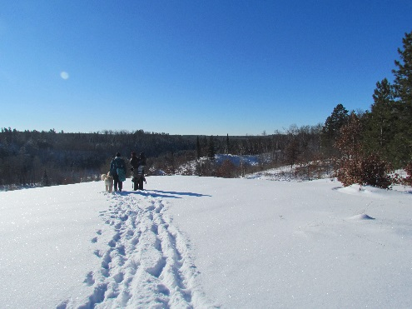
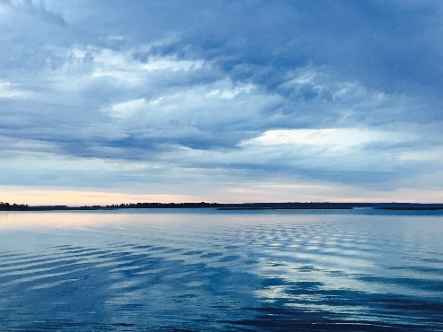
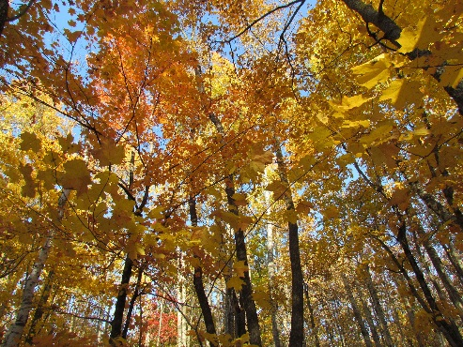

This outreach form does not constitute an application. The vacancy announcement will appear on the USAJOBS website. USDA is an equal opportunity provider employer and lender.
Outreach Notice Worksheet

USDA Forest Service | Eastern Region

Chippewa National Forest

Soil and Watershed Program Manager
GS 11/12 - 0470/1315
Please submit outreach response to Jim Gries by close of business October 20, 2017
Email: jgries@fs.fed.us, Phone: 218-407-5831, Fax: 218-335-8641

Name:
Date:
Mailing Address:
Phone:
E-Mail:
Are you a current Federal employee? Yes No
If you answered “yes” to the question above:
Current agency employed with:
Enter your current position title:
Series: Grade: Location:
Indicate the type of appointment you are currently under:
(Career, Career-Conditional, Excepted, Excepted VRA, Temporary, Term, PWD, Other)
How did you find out about this outreach notice?
If you are not a current permanent (Career or Career-Conditional) employee, are you eligible to be hired under any of the following special authorities?
Person with disabilities Disabled veteran with 30% compensable disability
Veterans Recruitment Act Veterans Employment Opportunities Act of 1998
Pathways Program Former Peace Corps Volunteer
Military Spouse Other – please explain
Land Management Workforce Flexibility Act
THANK YOU FOR YOUR INTEREST !

