ACE 240: Personal Financial Planning

Spring 2018 – Blended Section

Syllabus as of July 30, 2018

Instructor: Craig Lemoine, CFP®, PhD
Associate Clinical Professor
Director | Financial Planning Program
Department of Agricultural and Consumer Economics
302c Mumford Hall
craiglem@illinois.edu
Twitter & LinkedIn @HigherEdCraig

Teaching
Assistants: TBD

Suggested
Prerequisite: Sophomore standing, positive attitude, love of learning, basic
Spreadsheet/excel skills

Location: This class meets online using Compass. Though you are free to come by and watch the show live (I’m in Mumford hall 302c most of the time).

Time: Tuesday & Thursday; 11:00am – 12:20pm Central Time

Textbook: PFIN Version 4, 5 or 6. (Billingsley, R., Gitman, L. & Joehnk, M Revision updates have been minimal, a used copy is fine. We do not need access to textbook publisher online tools. The library may have copies on reserve.

Course
Overview: This course is an introduction to personal financial management including topics such as financial planning, asset management, credit, investments, insurance, and retirement planning. We’ll consider financial issues that are important to individuals and families at different points in the life cycle. This is an introductory survey course in personal finance and is intended to provide a practical introduction to these topics so that you can make better financial decisions throughout your career. This class will also introduce you to the field of personal financial planning.

Format: This course is synchronous and meets online twice a week. Treat it as you would any other lecture style course. The difference is that instead of going to a classroom, you can tune in from anywhere in the world. All lectures are archived and available on compass the following day.

Learning
Objectives: Students who successfully complete this course will have a functional understanding of the following topics:

1) The financial planning process
2) Preparation and use of financial statements
3) Time value of money calculations and concepts
4) Financing strategies and the prudent use of short, intermediate, and long term debt
5) Cash flow management
6) Long and short term investments
7) Analysis of retirement needs and common ways of funding them
8) Financial planning for special and adverse circumstances
9) Principles of risk and insurance
10) Income taxes
11) Rent versus buy decisions
12) Ten tribes of financial planning

Office Tuesday Mornings (8:30am – 10:30am)
Hours: Thursday Mornings (8:30am – 10:30am)
302c Mumford Hall

Website: There is a website on Compass 2g for this course. If you are properly enrolled, you should have access. Please verify immediately that you can access the ACE 240 website, Adobe Ulitimate and attend online lectures through Blackboard Collaborate. If not, please notify one of the TAs ASAP.

Podcast
Access: You need to be able to listen to the Planet Money Podcast. This podcast is available directly at no cost:
http://www.npr.org/podcasts/510289/planet-money
The podcast is also available through itunes and any number of other podcast streaming services.

Excel We will be using excel to calculate time value of money problems. Here’s a guide to get you started: https://www.youtube.com/watch?v=AuJvHoypfQU

Grading: Your grade will be determined by the following:

Choose Your Own Assignment 20%
Planet Money Podcast Paper 20%
Weekly Assessments 60%

Grading Scale:
Unless I announce otherwise, the grading scale will be:

A+ 97-100 | B+ 87-89 | C+ 77-79 | D+ 67-69
A 93-96 | B 83-86 | C 73-76 | D 63-66
A- 90-92 | B- 80-82 | C- 70-72 | D- 60-62
F below 60

Slides: Power point slides will be available before class. Slides will be posted to Compass.

Weekly Assessments
Assessments will be given through Compass. Due dates are listed on the course outline. Any content covered in readings or lecture may be assessed.

Students will have twelve total assessments over the semester. They will have up to twenty questions and each is worth 5 points towards your final course grade.

Students who miss an assessment window can email the teaching assistant to re-open the window. To encourage timely reading and participation assessment grades will be reduced one point for every day past the due date listed on the course outline.

Miscellaneous
Items: Please observe common courtesies in the classroom. If you plan on participating with audio, please mute your phone or mic if you are not talking. Limit chat box comments to course discussions. Be polite when students answer questions incorrectly.

Accessing Disability-related academic adjustments
To obtain disability-related academic adjustments and/or auxiliary aids, students with disabilities must contact the course instructor and the Disability Resources and Educational Services (DRES) as soon as possible. To contact DRES, you may visit 1207 S. Oak St., Champaign, call 333-4603, e-mail disability@illinois.edu or go to the DRES website. If you are concerned you have a disability-related condition that is impacting your academic progress, there are academic screening appointments available on campus that can help diagnosis a previously undiagnosed disability by visiting the DRES website and selecting “Sign-Up for an Academic Screening” at the bottom of the page.

Improving your skillsets
Writer’s Workshop / Undergrad Library 217-333-8796
http://www.cws.illinois.edu/workshop
http://disability.illinois.edu/strategies
http://www.counselingcenter.illinois.edu/self-help-brochures/
Also, most college offices and academic deans provide academic skills support and assistance for academically related and personal problems. Links to the appropriate college contact can be found by going to this website and selecting your college or school: http://illinois.edu/colleges/colleges.html

Overwhelmed, stressed or have anxiety?
If you are experiencing symptoms of anxiety or depression or are feeling overwhelmed, stressed, or in crisis, you can seek help through the following campus resources:
Counseling Center
206 Fred H. Turner Student Services Building
7:50 a.m.-5:00 p.m., Monday through Friday
Phone: 333-3704

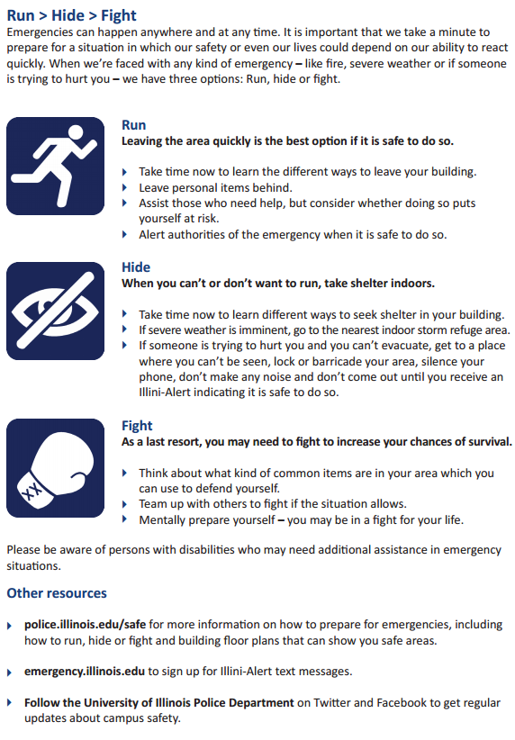

PLEASE TAKE THE TIME TO CAREFULLY READ THE FOLLOWING PAGE, WHICH IS PROVIDED BY THE CHANCELLOR’S OFFICE:

General Emergency Response Recommendations

These recommendations are provided by the Office of Campus Emergency Planning. There are two basic methods to respond in emergencies that may affect persons on campus, and more specifically, individual buildings: Building Evacuation (Get Out) and Shelter-In-Place (Stay In).

Only follow these actions if safe to do so. When in doubt, follow your instincts - you are your best advocate!

Building Evacuation (Get Out) — Action taken to leave an area for personal safety.
- Take the time to learn the different ways to leave your building Before there is an emergency.
- Evacuations are mandatory for fire alarms and when directed by authorities! No exceptions!
- Evacuate immediately. Pull manual fire alarm to prompt a response for others to evacuate.
- Take critical personal items only (keys, purse, and outerwear) and close doors behind you.
- Assist those who need help, but carefully consider whether you may put yourself at risk.
- Look for Exit signs indicating potential egress/escape routes.
- If you are not able to evacuate, go to an Area of Rescue Assistance, as indicated on the front page of this plan.
- Evacuate to Evacuation Assembly Area, as indicated on front page of this plan.
- Remain at Evacuation Assembly Area until additional instructions are given.
- Alert authorities to those who may need assistance.
- Do not re-enter building until informed by emergency response personnel that it is safe to return.

Shelter-in-Place (Stay In) — Action taken to seek immediate shelter indoors when emergency conditions do not warrant or allow evacuation.
- Severe Weather
  - If you are outside, proceed to the nearest protective building.
  - If sheltering-in-place due to severe weather, proceed to the identified Storm Refuge Area or to the lowest, most interior area of the building away from windows or hazardous equipment or materials.
- Security Threat
  - If you cannot safely evacuate, find a secure area within your building to stay and await further information.
  - Assist those who need help, but carefully consider whether you may put yourself at risk.
  - Once within a safe place, attempt to secure the space (i.e.: lock doors, close windows/blinds).
  - If unable to lock the door, secure it by any means possible.
  - Remain quiet, unless making noise would be beneficial to your safety (i.e.: rescue recovery).
  - Without jeopardizing your safety, try to obtain additional clarifying information by all possible means, including the Illini-Alert Emergency Text Notification System.

IMPORTANT NOTE: All items on this Syllabus are subject to change. Check the announcement page for any updates.

It’s a small office – so let me know ahead of time. Also bring some snacks or coffee. Professors love snacks and coffee.

