**Graphs for Statistics for EITP Websites**

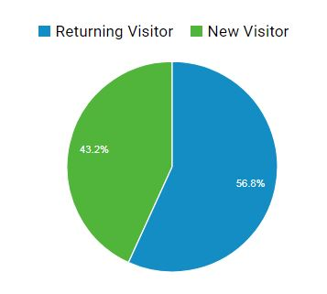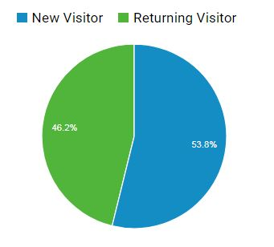

IllinoisEItraining.org (old site)

EITP.education.illinois.edu