Moving Forward: Kort’s spiral of learning and emotion

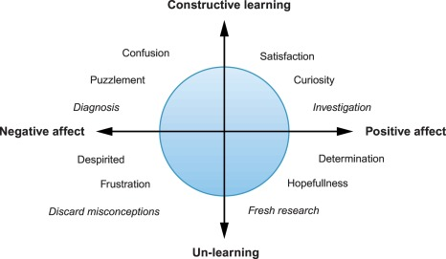

Adapted from: Kort, B., Reilly, R., & Picard, R. W. (2001). An affective model of interplay between emotions and learning: reengineering educational pedagogy-building a learning companion. Proceedings IEEE International Conference on Advanced Learning Technologies, Advanced Learning Technologies, 2001. Proceedings. IEEE International Conference on, Advanced Learning Technologies, 43–46. https://doi-org.proxy2.library.illinois.edu/10.1109/ICALT.2001.943850.

