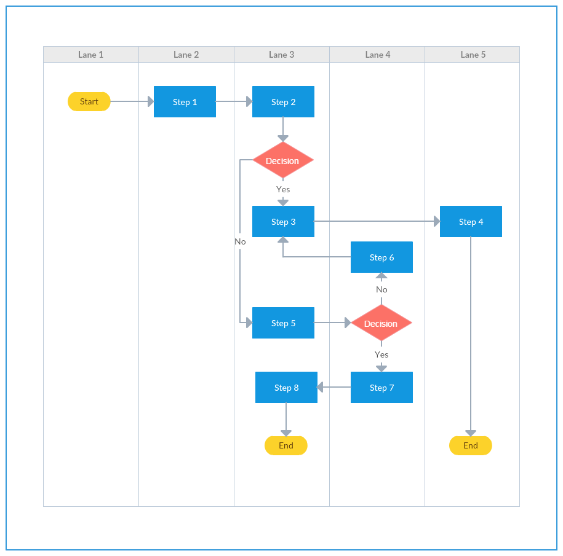
Moving Forward: Use these Tools in Your Classroom for Enabling Persistence

Enabling persistence: stop teaching (but not for long)

When students have control over their learning and can self-evaluate, they are more likely to invest in and stick with an assignment. This aspect of cognitive affect (or emotion in learning” is called the “Control value theory of achievement emotion (CVTAE)” but we’ll just say “control-value.”

However, students need assignments that are well-enough defined to that students can see an ‘end’ or likely ‘result’ that they can achieve, and they need a framework for evaluating themselves. We’ll call approaches to these sorts of processes “enabling persistence.”

Enabling student persistence during an assignment in which students give negative information or a counter-argument could include the following:
Give students choices: about what scenarios to say no to, about what the criteria for a ‘good reason’ is, or about what an appropriate outcome to a bad news situation is. Have students pair up and role play saying “no” in scenarios that have real stakes for them​
Help students see the value in evaluating refusals: point out how evaluating reasons contributes to an assignment’s success, how it can be used in their current realities and professional futures. Discuss how evaluating refusals is part of a universal ‘good’: a world of empathy, satisfied customers, good citizens, trusting partners and neighbors and teammates.
Partner with students: make rubrics together or explain you own reasons behind a rubric for this skill and ask students to ‘grade’ themselves or peers from time to time; model or suggest a process for the Bad New Letter assignment or for evaluating refusals and counterarguments, and ask them to tailor it so that it fits what they take to be their best draft.​
Offer formative assessments that ask students to respond directly to your comments.​
Connect your assessments with students’ futures: students can describe how their ability to evaluate refusals needs to improve so that they can succeed in school, as good citizens, as young professionals, or in other areas of their lives.

