Recording and Reflecting Questionnaire

Dear Students,

These worksheets will help you gain insight into your writing process. During the “Bad News Letter” assignment, as you work, please reflect on the emotions you’re experiencing.

When you are working on an assignment, you might feel many emotions – frustration, excitement, satisfaction, fear, worry, etc. You might even feel many of them at once. For example, it’s likely that you will feel both anxiety (about doing well) and satisfaction when you turn in an assignment, or that you will experience eagerness and annoyance and creativity during peer review. It’s okay to notice many different emotions during one activity. Please be willing to list emotions that might seem like they conflict with one another. To help you describe what you’re experiencing, use the Emotion Wheel at the end of this packet. You should spend about 20 minutes on each part of this questionnaire.

The “Bad News Letter” includes many activities, from reading the assignment to peer review and many more. As you are working on the activities listed on the next pages – on the Recording and Reflecting Questionnaire – please describe the emotions you are experiencing and explain, as best you can, why you think you are feeling those emotions. List and reflect on your emotions during the specific activity listed only.

Please also record what you are doing during an activity to work on an assignment. For example, are you thinking, asking questions of me or your peers, looking at the Wiki, finding a website, writing a sentence, choosing a word, etc. The ways to “work on an assignment” are almost infinite, so please don’t be hesitant to say whatever steps you are taking to “do” a task, whether you think they are good or efficient or clever, or not.

In this questionnaire, you may end up writing about negative emotions. Please tell your instructor or me, Andrew Moss (at apmoss@illinois.edu or 217-693-8879) if you experience undue stress or are uncomfortable. While you are completing this questionnaire, if you would not like others to see descriptions of your emotions, please take steps to work in a private space. Remember, you may opt out of this study if you choose.

When you are finished with each part of this questionnaire, please upload it to UIUC Box as a word or PDF document at this address: httpsampleaddress.

All best,
Andrew Moss

Recording and Reflecting Questionnaire Part 1.

Please type your answers into this questionnaire for parts A, B, and C.

______________

- What part of the assignment are you working on: drafting, research, peer review, reading instructor feedback, or other (please indicate an “other” activity if this is your answer)?

- While you were working on that part of the assignment, what emotions were you experiencing? List between 3-5, and then reflect on why you were experiencing them. Please feel free to use the emotion wheel on the next page to help you describe these emotions.

What emotions were your experiencing?
1.
2.
3.
4.
5.

Reflection: why were you experiencing these emotions?

- While you were working on this part of the assignment, record what were you doing or thinking in order to work on the assignment? List all the things that you did in order to work on the assignment. Describe what you were doing in a few sentences.

______________

Emotion Wheel

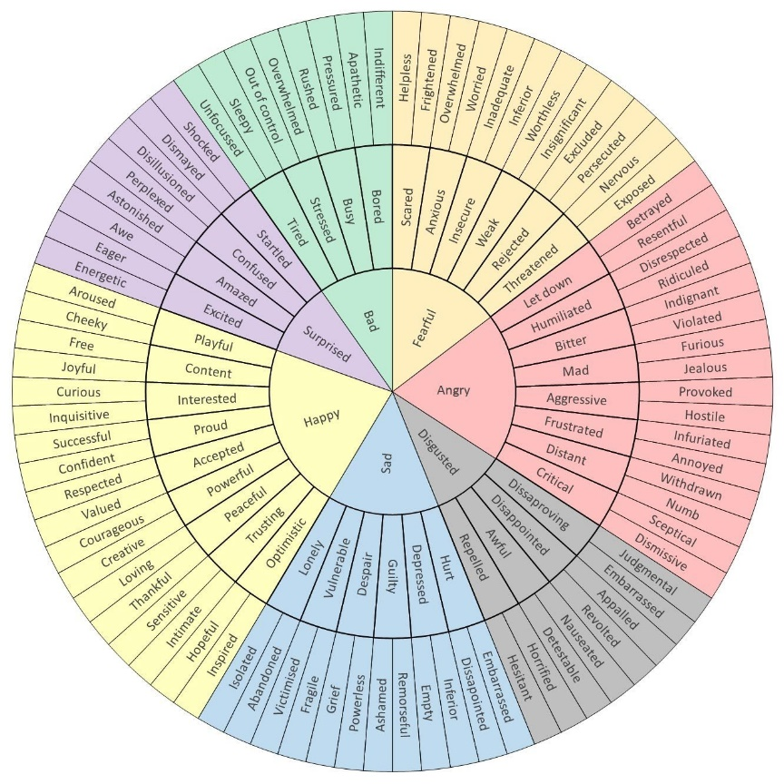

Recording and Reflecting Questionnaire Part 2.

Please type your answers into this questionnaire for parts A, B, and C.

______________

- What part of the assignment are you working on: drafting, research, peer review, reading instructor feedback, or other (please indicate an “other” activity if this is your answer)?

- While you were working on that part of the assignment, what emotions were you experiencing? List between 3-5, and then reflect on why you were experiencing them. Please feel free to use the emotion wheel on the next page to help you describe these emotions.

What emotions were your experiencing?
1.
2.
3.
4.
5.

Reflection: why were you experiencing these emotions?

- While you were working on this part of the assignment, record what were you doing or thinking in order to work on the assignment? List all the things that you did in order to work on the assignment. Describe what you were doing in a few sentences.

______________

Emotion Wheel

Recording and Reflecting Questionnaire Part 3.

Please type your answers into this questionnaire for parts A, B, and C.

______________

- What part of the assignment are you working on: drafting, research, peer review, reading instructor feedback, or other (please indicate an “other” activity if this is your answer)?

- While you were working on that part of the assignment, what emotions were you experiencing? List between 3-5, and then reflect on why you were experiencing them. Please feel free to use the emotion wheel on the next page to help you describe these emotions.

What emotions were your experiencing?
1.
2.
3.
4.
5.

Reflection: why were you experiencing these emotions?

- While you were working on this part of the assignment, record what were you doing or thinking in order to work on the assignment? List all the things that you did in order to work on the assignment. Describe what you were doing in a few sentences.

______________

Emotion Wheel

